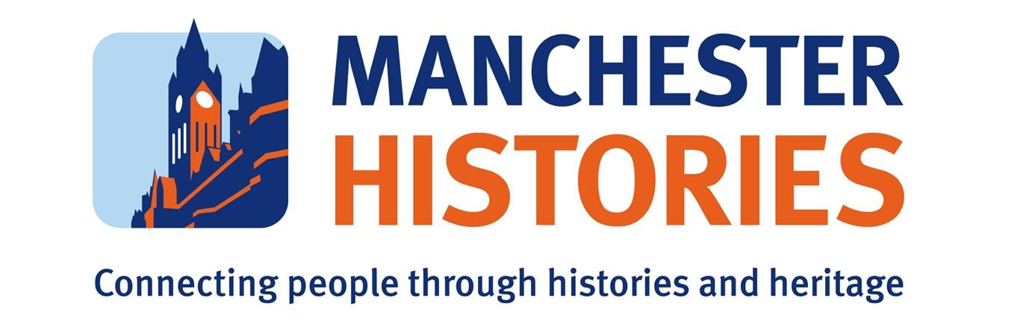
PRESS RELEASE: FOR IMMEDIATE RELEASE

Rocket 200 Steering Group Welcomes Two New Chairs to Lead the Rocket 200 Project with
Manchester Histories and Partners.

Manchester, UK – March 2024.

Manchester Histories, in collaboration with partners National Museums Liverpool, Metal, Manchester Science Museum, Manchester University, Liverpool City Council, Manchester City Council, St Helens Council and Network Rail, is proud to announce the appointment of two distinguished individuals to steer the Rocket 200 project towards its ambitious goals for 2030 after a public recruitment process. Professor Paul Salveson will serve as the Chair, accompanied by Jessica Bowles as the Vice Chair.

The Rocket 200 project was originally developed with Manchester Histories and partners in 2021 to explore how best to celebrate the 200th anniversary of the world’s first inter-city railway between Liverpool & Manchester. This encompassed several key objectives: fostering community regeneration along the railway line, delving into the depths of the UK's industrial past, shining a global spotlight on the North West as a hub of innovation and international influence, and providing a distinctive platform for cultural, engineering, and community engagement. During 2023 the Steering Group has been consulting and researching options for these activities with partners. It is now ready to develop the next phase of its programme, supported by Paul and Jessica’s leadership.

Professor Paul Salveson brings a wealth of experience and expertise to his role as Chair. With a career deeply rooted in the railway industry, Professor Salveson has been a trailblazer. He is credited with originating and developing the concept of 'community rail', which has led to establishing over twenty community-rail partnerships across the UK and Eastern Europe. As president of the South-East Lancashire Community Rail Partnership and a member of Bolton at Home's Operations Committee, his commitment to community engagement and empowerment is unwavering. Professor Salveson is a visiting Professor at Bolton and the University of Huddersfield in the Department of Transport Logistics where he shares his knowledge and expertise to the next generation of leaders. Additionally, his role as manager of the new Kents Bank Station Library underscores his dedication to preserving and promoting local history. Paul is also the author of the recently published book 'Lancastrians - Mills Mines and Minarets' which highlights the role of railways in the North's industrial transformation

Jessica Bowles will be joining him as Vice Chair and her public and private sector experience will complement Paul's. Jessica brings over 25 years of experience in generating investment and fostering growth in cities through expertise in economic policy, strategy, and commercial development. Her career has seen her emerge as a trusted leader in various capacities, including the senior civil service, local government in Manchester, and at the board level of Bruntwood, one of the UK’s most forward-thinking property companies. As Director of Strategic Partnerships and Impact at Bruntwood since April 2016, Jessica plays a pivotal role in shaping the company's strategic direction and driving cross-sector partnerships to enhance both business value and the wider economy.

Together, Paul and Jessica will spearhead Rocket 200 towards achieving its mission of celebrating and preserving the story of Rocket 200 past, present and future.

Manchester Histories is acting as the lead organisation for the project for the next three years. For media enquiries or further information, please contact:
Karen Shannon CEO Manchester Histories: karen@manchesterhistories.co.uk

About Manchester Histories:
Connecting people through histories and heritage.

History Matters. It connects people with those who've gone before and those who'll come after. We support people to explore these connections. It's why our work is vital.

Manchester Histories is an award-winning charity that works collaboratively to reveal and celebrate the stories of the people and places of Greater Manchester and beyond. It connects people through histories and heritage to explore the past and shape the future, valuing all voices in the telling, preserving, and celebrating stories.

Manchester Histories was established in 2012 and delivers a yearlong public and community engagement programme, and the biennial Manchester Histories Festival is now in its 9th edition. Manchester Histories is proud to be part of GMAST (Greater Manchester Arts Sustainability Team). This network brings together the cultural and creative community across Greater Manchester to address the climate and ecological crisis.

Past projects include Peterloo 2019, a project to mark the 200th anniversary of the Peterloo Massacre; DigiFest 2020, a celebration and recognition of the 50th anniversary of the Chronically Sick and Disabled Persons Act (1970); Manchester Histories Festival 2022, History of Climate Change which explored the local and global climate crisis.
www.manchesterhistories.co.uk
Facebook facebook.com/manchesterhistories
Instagram instagram.com/manchesterhistories
Twitter (X) twitter.com/mcrhistfest

